Framework Design Specification

A report describing the detailed design requirements for the Network Appliance Service Utilisation Framework

Version: 0.1a

By

Paul Fergus

Supervised by

Dr. Martin Hanneghan and Prof. Madjid Merabti

Networked Appliances Lab
School of Computing and Mathematical Sciences
Liverpool John Moores University

Table of Contents
Table of Contents ii
Table of Figures iv
1 Introduction 2
1.1 Sections 2
1.2 Release Information 2
1.3 Reader Level 2
1.4 The Specification Process 2
1.5 Version Information 3
2 Framework Specification Overview 3
2.1 Introduction 3
3 Peer-to-Peer Networking with the framework 3
3.1 The IP2PImpl Interface 3
3.2 The IDiscoveryService Interface 4
3.3 The IEndPointService Interface 5
3.4 The IPeerServiceManager Interface 6
4 Services 6
4.1 Implementation Services 8
4.2 Peer Services 8
5 Descriptions 9
5.1 Design Requirements 9
5.2 Semantic Mark-up Language 10
5.3 Describing Device Capabilities 10
5.3.1 IDeviceCapabilityAdvertisement 11
5.3.2 IDeviceCapabilityProfile 11
5.4 Requests 13
5.4.1 Device requests 13
5.4.2 Service requests 13
5.5 Device Descriptions 13
5.6 Service Descriptions 13
5.6.1 Writing Service Descriptions 13
6 Discovery 13
6.1 Groups 13
6.2 Peer Groups 13
6.3 Discovery Mechanisms 13
6.3.1 Discovery Service 13
6.3.2 EndPoint Service 13
7 Semantic Device Capability Matching 13
8 Semantic Service Capability Matching 13
8.1 Abstract Matching 13
8.2 Concrete Matching 13
8.3 Semantic Interoperability and Signature Matching 13
8.3.1 IOPE Matching 13
8.3.2 Signature Matching 13
8.3.2.1 Direct Matches 13
8.3.2.2 Indirect Matches 13
8.3.2.3 IOPE Conflict Resolution 13
8.4 Extended Interfaces 13
8.4.1 Control 13
9 Dynamic Service Composition 13
10 Control 13
10.1 Synchronous Service Invocation 13
10.2 Asynchronous Service Invocation 13
11 Presentation 13
12 Security 13
12.1 Privacy 13
12.2 Authentication 13
12.3 Integrity 14
12.4 Non-repudiation 14
REFERENCES 14

Table of Figures

Figure 1 IP2PImpl Class Diagram 3
Figure 2 Core service provided devices 7
Figure 3 Implementation Services Class Diagram 8
Figure 4 Peer Services Class Diagram 8
Figure 5 Semantic interoperability using best practice repositories 9
Figure 6 Device Capability Advertisement Class Diagram 11

ABSTRACT
User demands and technological advances are driving the complex integration between heterogeneous devices, and moving us closer to pervasive and ubiquitous computing environments. The home of the future will include an embedded ‘intelligence’ and accommodate a flexible integration of services to perform functions that are only limited by our imagination. The family car and working environment will be closely integrated allowing the children to watch a movie on digital screens embedded in the back of the driver and passenger seats, by directly streaming the digital content from the DVD player located in the living room of your home. Furthermore you will be able to access and listen to music stored on your MP3 player, which you accordingly left at the office on Friday night, via your wireless enabled headphones, without interrupting the children’s viewing experience. This vision will expose the functionalities offered by devices as independent services and capitalise on advances made in global communications to revolutionise the way we interact with the plethora of devices that surround us.
This vision will require us to perceive and interact with our devices in ways we have never experienced before. The constraints placed on us by manufacturers and service providers will become a thing of the past as the flexible and seamless integration of distributed devices become common place. One of the challenges is to expose the functions offered by devices as services. Manufactures will need to re-engineer most common household appliances and produce solutions that better utilise the functionalities a particular device offers. A framework needs to be developed that allows services to be described using machine-processible semantics enabling devices to make informed decisions regarding the composition process once a potential service has been discovered. The framework needs to utilise advances made in Peer-to-Peer technologies and provide discovery mechanisms that ensure collaborations between devices encompass vocabularies that support machine-level understanding.
In this report we describe how we have, in part begun to address these challenges using the Networked Appliance Service Utilisation Framework (NASUF) we developed including the Distributed Semantic Unstructured Services (DiSUS) protocol we developed and the Distributed Emergent Semantics (DistrES) and Semantic Interoperability and Signature Matching (SISM) algorithms we developed. We explain how NASUF implements the DiSUS protocol to publish and discover unstructured services within P2P networks, the DistrES algorithm to manage and evolve ontological information over time based on general consensus, and the SISM algorithm to dynamically compose services and resolve terminology differences that occur.

Introduction
The Networked Appliance Service Utilisation Framework (NASUF) is a work in progress and provides the finds so far for my PhD Research. The framework is designed to allow service-enabled devices to be seamlessly integrated within Peer-to-Peer (P2P) networks. Once these devices have been deployed they can expose the functions they provide as independent services, which are described and discovered using machine-processable semantics.
The framework is flexible and does not place any constraints on the underlying technologies used. It is designed to provide a set of core interfaces that must be implemented in order to enable services to be effectively described and discovered within P2P networks. We do not place any constraints on the underlying communication protocols used or the P2P technology used to deploy devices and the services they provide. Furthermore we do not place any constraints on the service technology used and envisage that a plethora of services could be used and integrated with relative ease.
This is the first release of this specification and is still very much a work in progress. Its primary goal is to define a set of generic interfaces that support the above mentioned requirements.

Sections
Need to do

Release Information
This document is a work in progress and is our initial first draft. We describe this release as an unstable release that is designed to prompt discussions in order to refine our overall framework design. Its primary function is to highlight the possibilities our framework provides and to prompt further investigation into other potential uses.

Reader Level
This document can be used by a number of readers, who are concerned with the framework from a number of different viewpoints.
- Service Developers
- Distributed Computing Developers
- Semantic Web Developers
- Networked Appliance Developers
- Framework Designers
- Enterprise Architects
This specification assumes that the reader is converse with UML and more specifically Use Case design. The specification is language and protocol agnostic and could be used to implement service-enabled networked appliances using a number of different languages, which implement a number of different communication protocols.

The Specification Process
The specification process is performed as part of PhD research, with a number of researchers and Academic staff involved in its creation. The specification is reviewed by a subject matter expert within the fields of UML modelling, P2P technologies, Semantic Web technologies and Networked Appliances. We hope that as this specification evolves it will be opened up to a much wider audience, whereby contributions can be made by a number of expert groups.
The current process involves the framework design using a number of UML models. At predetermined millstones the designs are submitted to the subject matter expert, which are then evaluated. Any changes are performed and all design decisions are challenged. Consequently, new milestones to address the issues raised. This process continues until defined work packages are completed.

Version Information
This version is not designed to be used for implementations. This version is designed to prompt discussion on our framework to ensure that the framework captures all the required functionality.

Framework Specification Overview

Introduction

Peer-to-Peer Networking with the framework
Within our framework we do not place any constraints on the underlying P2P technology used, i.e. JXTA, Gnutella, FreeNet as the implementation details are abstracted away using the core interfaces we define within this section. This provides device manufacturers with a level of flexibility, which does not constrain them to one particular solution. The following sections describe all the core interfaces that must be implemented to enable devices to connect to the P2P network. The high-level class diagram for the P2P network is illustrated in Figure 1.
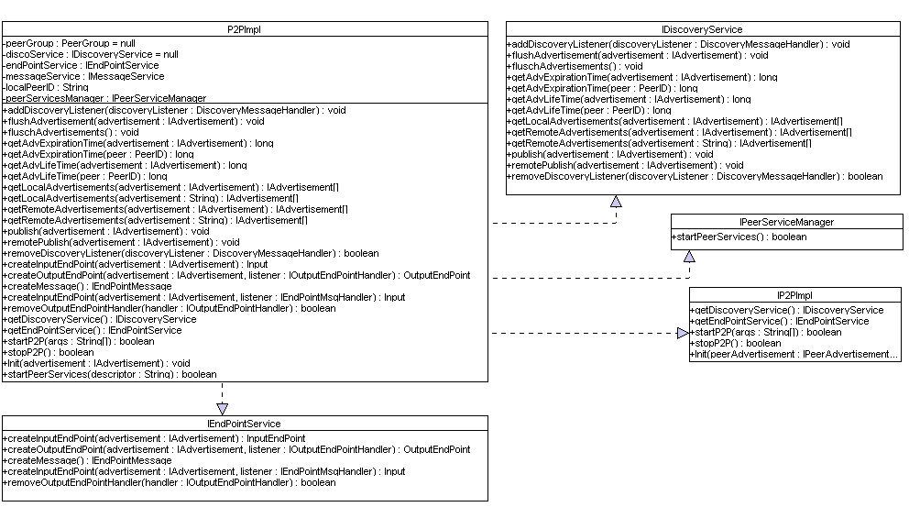
Figure 1 IP2PImpl Class Diagram

The IP2PImpl Interface
This interface forms a level of abstraction between the application level and the underlying P2P implementation. The methods provided by the IP2PImpl interfaces are described in Table 1.
Method |  | Description
getDiscoveryService() : IDiscoveryService | This method returns the Discovery Service, which is used to discover resources within the network such as Peers, Peer Groups and Peer Services.
getEndPointService() : IEndPointService | This method returns the End Point Service. This service allows devices to bind to peer services provided by other devices within the network.
Init(advertisement : IAdvertisement) void | The init method publishes the required advertisements that allow the device to be discovered by other peers within the network. This method takes one parameter, which is a Peer Advertisement. Advertisements will be discussed in detail in Section ?
startP2P(args : String[]) : Boolean | This method starts the underlying P2P implementation. It has one argument, which allows a number of arguments to be passed and used within the application. Once the P2P implementation is started, the services it provides become available on the network. A Boolean value is passed back to the calling method to indicate success or failure.
stopP2P() : Boolean | This method stops the P2P implementation. A Boolean value is passed back to the calling method to indicate success or failure.
Init(peerAdvertisement : IPeerAdvertisement) : void | This method publishes the peer within the P2P network. The parameter passed in provides information regarding the peers capabilities, such as hardware specification, software specification, and network capabilities.
Table 1: Methods provided by the IP2PImpl Interface

The IDiscoveryService Interface
The underlying P2P implementation is required to implement the IDiscoveryService interface. This interface provides a number of methods that must be implemented, which allows the device to add discovery listeners, process advertisements and publish the services it provides locally and remotely. In Table 2 we provide a list of the methods used in the IDiscoveryService interface and provide a brief description.
Method |  | Description
addDiscoveryListener(discoveryListener : DiscoveryMessageHandler : void | This method allows the P2P Implementation to add an action listener for incoming discovery messages. This ensures that messages are propagated within the network asynchronously.
flushAdvertisement(advertisement : IAdvertisement) : void | This method allows a particular advertisement to be flushed from the local cache. This method can be used to ensure that all stale references are removed.
flushAdvertisements() : void | This method flushes all the advertisements found in the local cache.
getAdvExpirationTime(advertisement : IAdvertisement) : long | This method returns the maximum lifetime granted for the advertisement passed into the method. The value returned is in milliseconds and is used to indicate how long the advertisement should be cached for peers other than the publisher.
getAdvExpirationTime(peerID : IPeerID) : long | This method returns the maximum lifetime granted for the peer ID passed into the method. The value returned is in milliseconds and is used to indicate how long the advertisement should be cached for peers other than the publisher.
getAdvLifeTime(advertisement : IAdvertisement) : long | This method returns the maximum lifetime granted for the advertisement passed into the method. The value returned is in milliseconds and is used to indicate how long the advertisement should be kept in the local cache for.
getAdvLifeTime(advertisement: IAdvertisement) : long | This method returns a maximum lifetime granted for the peer ID passed into the method. The value returned is in milliseconds and is used to indicate how long the advertisement should be kept in the local cache for.
getLocalAdvertisements(advertisement : IAdvertisement) : IAdvertisements[] | This method returns a list of particular advertisements from the local cache.
getRemoteAdvertisements(advertisement : IAdvertisement) : IAdvertisement[] | This method returns a list of particular advertisements from the P2P network.
publish(advertisement : IAdvertisement) : void | This method publishes an advertisement in the devices local cache.
remotePublish(advertisement : IAdvertisement) : void | This method publishes an advertisement within the P2P network.
removeDiscoveryListener(discoveryListener : IDiscoveryMessageHandler) : Boolean | This method removes a particular discovery listener and returns a Boolean value indicating whether the action was successful or not.
Table 2: Describes the methods provided by the IDiscoveryService Interface

The IEndPointService Interface
The IDiscoveryService interface allows devices to discover other devices and the services they offer within the network. The IEndPointService interface allows devices to connect to these services in order to invoke the functions they provide. Device manufacturers must also implement this interface. In Table 3 we provide a list of the methods used in the IEndPointService interface and provide a brief description.
Method |  | Description
createInputEndPoint(advertisement : IAdvertisement) : InputEndPoint | This method allows the device to create an input endpoint based on the peer and service information contained in the advertisement
createInputEndPoint(advertisement : IAdvertisement, listener : IEndPointMsgHandler) : InputEndPoint | This method allows the device to create an input endpoint based on the peer and the service information contained in the advertisement. The second parameter allows the device to register an IEndPointMsgHandler for asynchronous method invocation.
createOutputEndPoint(advertisement : IAdvertisement, listener : IOutputEndPointHandler) : OutputEndPoint | This method allows the device to create an output endpoint based on the peer and the service information contained in the advertisement. The second parameter allows the device to register an IOutputEndPoint Handler for asynchronous method invocation.
createMessage() : IEndPointMessage | This method allows the device to create default endpoint messages, which contain the core parameter information relating to the device, such as PeerID and advertisement expiration timeout
removeOutputEndPointHandler(handler : IOutputEndPointHandler) : Boolean | This method allows the device to remove the handler described in the parameter passed to the method. This method returns a Boolean value to indicate that the operation was successful or not.
Table 3: The IEndPointService Interface

The IPeerServiceManager Interface
A device may choice to offer zero or more services to other devices within the network, which may include the core framework services and/or the application specific services the device has. In order to achieve this device manufacturers need to develop theses peer services and publish their capabilities – peer services are discussed in more detail later in this document. The methods supported by the IPeerServiceManager interface are illustrated in Table 4.

Method |  | Description
startPeerServices() : Boolean | This method starts all the peer services provided by the device. This includes the core peer services and the application specific peer services.
Table 4: The IPeerServiceManager Interface

Services
The framework is based on a Service Oriented Architecture (SOA), whereby applications are developed by dynamically discovering and composing distributed services. The minimum requirements for a peer are to implement a P2P implementation and the DiSUS service. A peer may chose to implement several optional services called DistrES [1] and SISM [ref] that allow the peer to manage ontological structures that describe the services provided by the peer and to semantically match service requests with service descriptions.
The DistrES Service enables peers to maintain conceptual knowledge structures provided by manufacturers and evolve structures based on general consensus. This service may be classed as resource and process intensive therefore a peer may chose not to implement its own DistrES service but rather use a remote service to perform this function. This is an important part of the framework that enables resource limited devices to participate and outsource process intensive services to more capable devices. For example a mobile phone may not offer any services however it may still chose to use services in the peer to peer network. In this instance there is not need to implement the DistrES Service because the mobile phone has not knowledge structures to maintain.
The SISM Service enables peers to semantically match service requests with service descriptions. This service uses the DistrES Service to resolve and differences between terminology used in the two descriptions. Service requests describe the capabilities sought after in the candidate service and the service descriptions describe the capabilities the service supports. The SISM Service compares the capabilities between the two descriptions and returns any matching services to the requesting peer. This is an optional service that does not need to be implemented if the device is resource limited. Returning to our mobile phone; the phone may host a number of services, however it may not have the processing capabilities to perform matches between service requests and service descriptions. In this instance the mobile phone can outsource the matching process to a SISM Service on a device with better capabilities. A typical scenario is illustrated in Figure 2, which describes three, peers that implement zero or more core services.
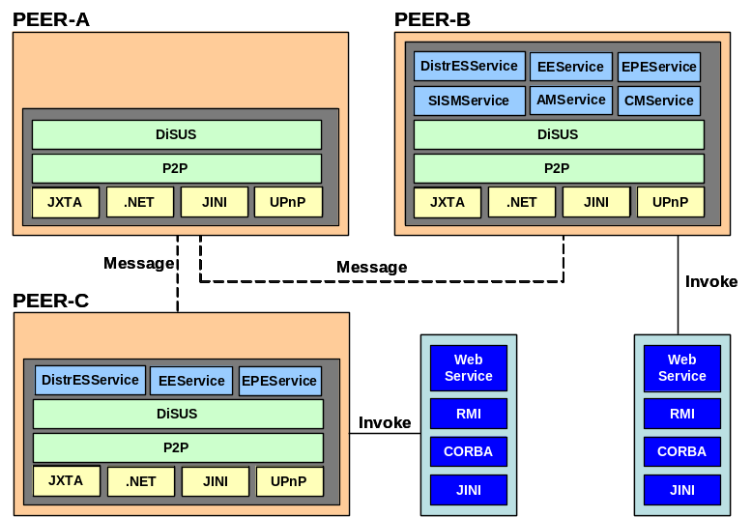
Figure 2 Core service provided devices
In Figure x illustrates three different peers, which offer zero or more services. Peer-A only implements the minimal core services required to participate within the framework environment, however it can discover and use distributed services making it just as capable as Peer-B. In the framework it is not compulsory for a peer to offer the optional services DistrES and SISM. For example Peer-A does not offer a DistrES or SISM service, however it can discover the services offered by other devices within the P2P network. For example it could use the DistrES Service offered by Peer-C and the SISM Service offered by Peer-B. What makes the framework more powerful is the ability to dynamically recover from service failure during run-time. For example if Peer-A uses the DistrES Service offered by Peer-C and this service becomes unavailable for some reason then the DiSUS implementation on Peer-A can dynamically discover and use another DistrES Service provided by another peer, for example the DistrES Service provided by Peer-B.
So far the framework describes the core services need, however the framework supports peer specific services that allow devices to interact and control devices via the services the device exposes. For example Peer-B may be a speaker, which provides a service that allows other devices to instruct the speaker to process an audio stream or increase and decrease the volume. These are called Peer Services. The service implementation is not pre-determined by the framework and enables device manufacturers to implement services in any technology, for example Web Services, RMI, Corba and Jini. This flexibility enables existing and heterogeneous services to be integrated and composed into set configurations.

Implementation Services
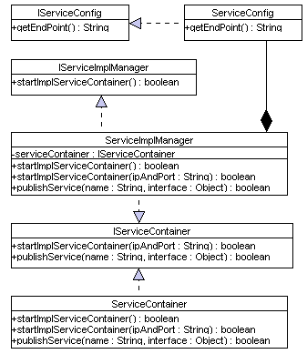
Figure 3 Implementation Services Class Diagram

Peer Services
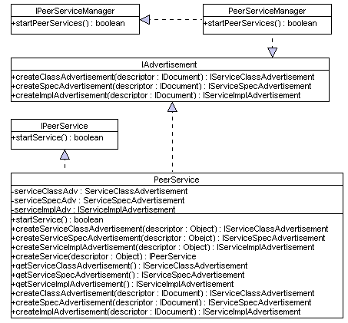
Figure 4 Peer Services Class Diagram

Descriptions

Design Requirements
Typically service descriptions and service requests are based on key-value pair matching [ref]. Although such systems use syntactic interoperability they do not support semantic interoperability. The service descriptions and service requests are matched based on an exact match between key-value pairs. No consideration is placed on the semantics of the key-value pairs being processed. For example a key-value pair in the service request could be ‘Media-Film’, whilst the key-value pair in the service description could be ‘Media-Movie’. In typical key-value pair systems this match would fail even though the value ‘Film’ and the value ‘Movie’ are conceptually equivalent. Figure 5 illustrates how we overcome this problem in our framework.

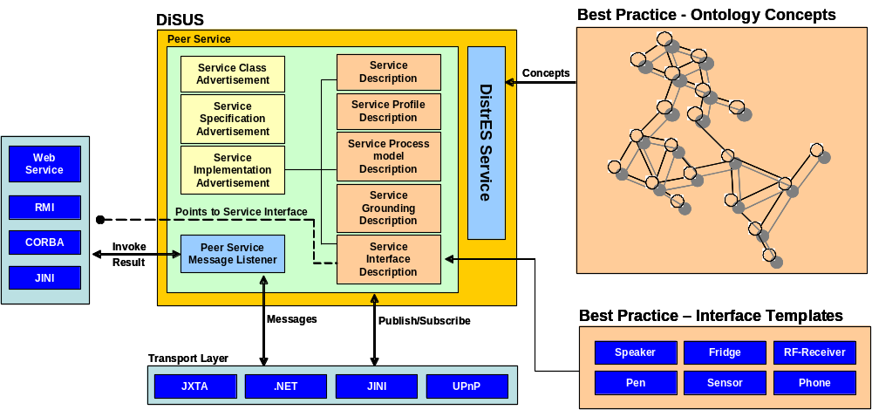
Figure 5 Semantic interoperability using best practice repositories
DiSUS can host zero or more services and offer these services to the peer network. Each service must be described using three core advertisements that allow them to be discovered and used in the network. These core advertisements are the ‘Service Class Advertisement’, the ‘Service Specification Advertisement’ and the ‘Service implementation Advertisement’. The ‘Service Implementation Advertisement’ itself contains metadata that describes the services capabilities using machine processable semantics. There are five metadata files that describe the service from a number of viewpoints, which are the ‘Service Description’, the ‘Service Profile’, the ‘Service Process Model’, the ‘Service Grounding’ and the ‘Service Interface’.
The service advertisements and the service descriptions allow the service to be discovered and processed to determine the capabilities the service supports. Devices may optinally implement the DistrES service that contains ontological concepts that best describe the device and the services it provides. The ontology structures are maintained and evolved by the DistrES service over time to ensure semantic interoperability between different vocabularies supported by different devices. Manufactures will choice and implement these concepts from best practice forums that will describe concepts relating to a number of services provided by a plethora of Networked Appliances, however manufacturers are free to implement their own concepts and extend the meaning of existing concepts.
The framework does not necessitate the need to use pre-defined service interfaces, however there will be a best practice forum describing a number of well defined service interfaces for a plethora of services provided by Networked Appliances.
The forums aim to promote reuse and effective semantic interoperability between the services within the P2P network. Service interfaces define the common signatures used by specific services, whilst ontological structures will provide a common way of describing those signatures.
The framework does not place any constraints on the types of services that may be provided by a device in the P2P network. Service implementations are determined by device manufacturers, who may decide to use Web Services, RMI, Jini or Corba based service implementations.
  - Semantic Mark-up Language

Describing Device Capabilities
In this section we define the interfaces required to describe the devices capabilities using machine-processable semantics. Devices will be deployed within the P2P network and will inherently support different capabilities. It is important that the devices capabilities are well understood before we use the services it provides. For example a DVD player could stream the movie data directly to a TV screen without encountering any difficulties, because TV’s are designed for such tasks and as such are capable of processing high-quality video formats such as MPEG4. However this is not the case for devices that able to display movies, which have limited processing capabilities such as a 3G phone. In this instance we may make a conscious decision to either transcode the DVD format into a format that is more suitable to such devices capabilities or disallow a DVD Player to stream a movie to such resource limited devices.
The devices capabilities will be defined by device manufacturers using the core interfaces described within this section. We do not place any constraints on the vocabulary used within these descriptions, however vocabularies from best practice repositories can be used to ensure that the devices developed by manufacturers will be interoperable with other devices in the P2P network. Our framework will however try to resolve any vocabulary differences using the semantic interoperability bridges described within this document.
In order to achieve this, devices need to describe their capabilities so that other devices can determine what they are capable of doing and whether the device is suitable or not. This is achieved by implementing several core interfaces that allow devices to create a profile that describes the components contained within the profile and the attributes associated with individual components. A profile can contain any number of components to describe the hardware capabilities supported by the device, the software it has installed and the network interface it uses. We envisage that these will be the core components, however the device manufacturer is free to implement custom components, which makes our solution extensible and highly flexible.
Our approach differences from other initiatives such as Composite Capability/Preference Profiles (CC/PP) [2], because we are not reliant on carefully controlled vocabularies. This solution provides no mechanisms to support semantic interoperability between terms that are syntactically different but semantically equivalent. Although device descriptions are searialised using RDF(S), the specification does not concern itself with the subsumption proprieties provided by RDF(S) to try and determine the relationships between conflicting key value pairs described within components of a devices profile [2]. Each of these interfaces is described in the following sections. The high-level class diagram for the Device Capability Advertisement is illustrated in Figure 6.
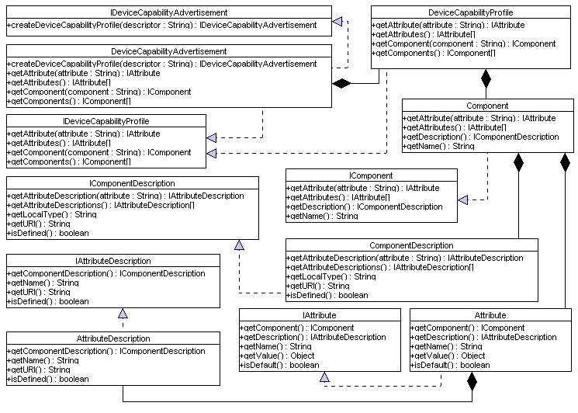
Figure 6 Device Capability Advertisement Class Diagram

IDeviceCapabilityAdvertisement
This interface must be implemented by devices and along with other peer advertisements, such as service advertisements, it must be implemented in order to describe the devices capabilities. The interface methods are illustrated in Table 5.

Method |  | Description
createDeviceCapabilityProfile(descriptor : String) : IDeviceCapabilityAdvertisement | This method takes one parameter, which is a descriptor file serialised to a string that contains the components used to describe the devices capabilities, including the attributes associated with each component.
Table 5: The IDeviceCapabilityAdvertisement Interface

IDeviceCapabilityProfile
Each device has a profile, which contains a number of components, which themselves contain a number of associated attributes. The profile acts like a grouping mechanism for all the components the device describes. The interface methods and a brief description of each are described in Table 6.

Method |  | Description
getAttribute(attribute : String) : IAttribute | This method returns an attribute as specified in the parameter, if the parameter exists in a particular component.
getAttributes() : IAttribute[] | This method returns all the attributes that exist within all components in the profile.
getComponent(component : String) : IComponent | This method returns a component as specified in the parameter, if the component exists in the profile.
getComponents() : IComponent[] | This method returns all the components that exist with the profile.
Table 6: The IDeviceCapabilityProfile

Requests

Device requests

Service requests

Device Descriptions

Service Descriptions

Writing Service Descriptions

Discovery
  - Groups
  - Peer Groups
  - Discovery Mechanisms

Discovery Service

EndPoint Service

Semantic Device Capability Matching

Semantic Service Capability Matching

Abstract Matching

Concrete Matching

Semantic Interoperability and Signature Matching

IOPE Matching

Signature Matching

Direct Matches

Indirect Matches

IOPE Conflict Resolution
  - Extended Interfaces

Control

Dynamic Service Composition

Control

Synchronous Service Invocation

Asynchronous Service Invocation

Presentation

Security

Privacy
The main idea behind privacy is that the framework ensures that there is no eavesdropping on the communication channel

Authentication
In the framework the system ensures that the communicating peers are who they say they are.

Integrity
Integrity refers to the integrity of the messages sent between peers – what is sent by a peer is what is received by another peer.

Non-repudiation
Non-repudiation ensures that a peer cannot take back a transaction completed at an earlier date.

REFERENCES

